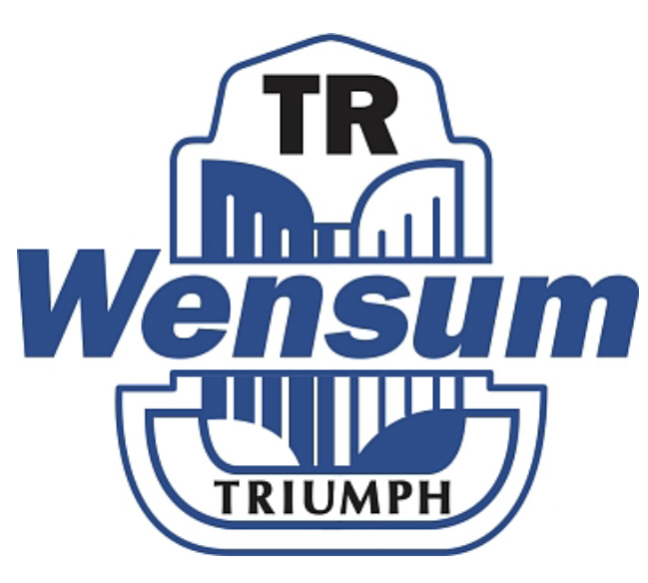
Newsletter September onwards 2022
Events 3rd September Northwold bike & classic car show
4th September Brisley Classic car show
4th September Stradsett Hall classic car auction
4th September Glemham Hall classic car show
11th September Kings Lynn Classic car Show
12th September – Social meeting at The Bird in Hand Wreningham
17th September Arminghall classic car & auto jumble show
18th September Mattishall Classic car meet up
27th September Whitwell Station social meet up

